HYBRID SINGLE-PHASE AC–AC MODULAR MULTILEVEL DSCC CONVERTERS WITH MODULATION AND DC-LINK VOLTAGE RIPPLE IMPROVEMENT
ABSTRACT
This paper proposes two hybrid topologies based on a single ac–ac modular multilevel cascade cascade converter (MMCC) with double-star chopper cells (DSCC), in each of which a voltage reference technique (VRT) is associated for generating the output modulating references. In doing so, either the gridconnected leg or the shared leg can be switched at the line frequency, thus reducing the switching losses. For proper operation of theVRTsinreal-time,theinputandoutputconvertervoltagesmust be in sync, hence a synchronization technique is proposed. Furthermore, when no dc-link capacitor is used in a DSCC converter, the dc-link is subjected to voltage ripples derived from the pulsewidth modulation (PWM) technique. In that case, high-frequency PWM techniquescanproducehigh-frequencycomponentsacrossthearm inductors, which are reflected in the dc-link. Therefore, this paper focuses on the operability of the hybrid modular multilevel DSCC converters, but also on the investigation of the proposed VRTs in reducing the dc-link voltage ripple on the conventional DSCC converter using PWM with phase-shifted carriers (PSCs). Simulated and experimental results are presented to validate the proposed techniques and converters.

BLOCK DIAGRAM FOR PROPOSED SYSTEM
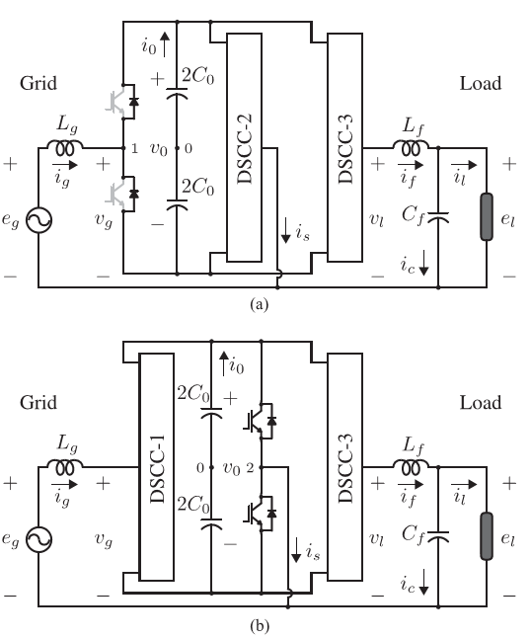
Fig. 1Proposed hybrid single-phase ac–ac DSCC converters: (a) for VRT-1; (b) for VRT-2.
DESIGNG SOFTWARE AND TOOLS:
MAT LAB /SIMULATION Software and simu power systems tools are used. Mainly control system tools, power electronics and electrical elements tools are used.

